***Thought Process / Plan***

1. *Create pseudo, admin accounts. (assume: admin accounts already exist and will be recognized by the system created)*
2. *Create login UI for support operatives (assume: is stored separately to customer data) - i.e. allow entering username & password*
3. *Login details have to pass validation (i.e. match details of login & password to a separate support operatives’ admin account database)*
4. *Admin details (passwords) can also be hashed (*can be achieved by* *Generating a long random salt using a CSPRNG – e.g. using* *RNGCryptoServiceProvider() and then concatenate the entered password to the salt and hash it with a hashing function (e.g. the PBKDF2 hashing algorithm)*
5. *Login button leads to customer data UI*
6. *data UI - Enter data (input & edit option)*
7. *Name, Address, Phone number, Email address, Username, Password*
8. *After password is entered. It is stored as a hash (*)*
9. *data UI - View data in table:*
10. *Name, Address, Phone number, Email address, Username, Password – can be viewed in a table after inputted (assume: support operatives cannot/can only view hashed version of password – because its weird to be able to view customer passwords.)*
11. *Input & other validations to ensure accurate content and no input errors (e.g., predefined password requirements as specified (must be 10 characters minimum, contain 1 Upper, 1 lower, 1 number and 1 non alpha numeric character: can be achieved by* using Microsoft.AspNet.Identity*) , email address has to contain ‘@’, phone number should be certain number of digits and appear to be valid)*

*Unit tests could be completed for each of the points above. Some examples can be seen below.*

***Tested Examples:***

*(please note that I understand Visual Studio is capable of enabling its own unit tests, however due to time purposes I was unable to learn to do this)*

This shows UI tested for 6(i) and 7(i)*:*

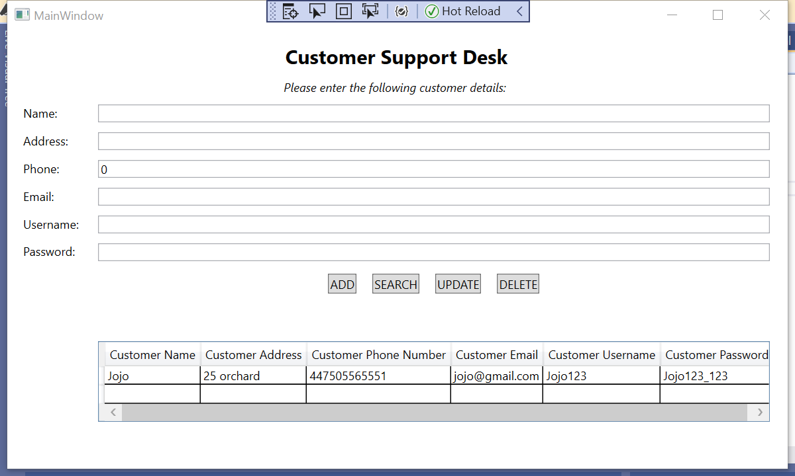

This shows the incomplete UI tested for 2)

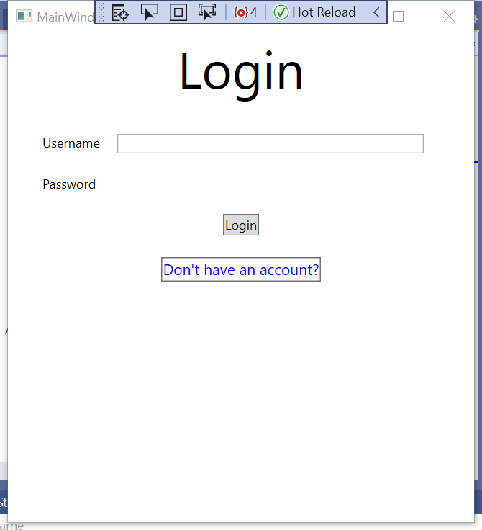

To run code for this, please switch to login view in the MainWindow.xaml

xmlns:vw="clr-namespace:customersupport.View" >

<!-- xmlns:vm="clr-namespace:customersupport.View"-->

<Grid>

<vw:AddCustomerView></vw:AddCustomerView>

<!-- <vm:LoginViews></vm:LoginViews> -->